目录

File & folder 3

Test case 3

C查阅工具 6

常用文件 6

头文件关系 8

Code analysis 8

soc_new_request 8

init_ip_request 9

dma_populate_request 10

soc_allocate 10

dma_init_context 11

create_context_dma_inst 11

create_context_dma3 12

soc_get_context_pointer 13

ip_request_t 13

dma_context_t 14

DMA3_CONTEXT 14

dma3_reg_check_reset 15

RE32 16

dma3_reg_check_complement_32bit 16

WRE32 18

Register 18

中断工作流程 18

dma3_setup_int(dma3_context); 18

dma3_setup_hw 19

Register definition 21

DMA3_TCD_SADDR 21

DMA3_TCD_SOFF 22

DMA3_TCD_ATTR 23

DMA3_TCD_NBYTES 24

DMA3_TCD_SLAST 26

DMA3_TCD_DADDR 28

DMA3_TCD_CITER 29

DMA3_TCD_DOFF 30

DMA3_TCD_DLAST 31

DMA3_TCD_BITER 32

DMA3_TCD_CSR 34

DMA3_CH_SBR 37

DMA3_CH_CSR 39

DMA3_CH_PRI 40

DMA3_GRPRI 41

Makefile 42

Testbench overview knowledge 43

Module description 44

TCD 44

Channel preemption 45

Scat/gather 46

Example 46

Channel linking 47

Example 47

Channel SBR 48

# File & folder

## Test case

* Test case所在文件夹：

/home/imxrt1180_verif3/richard_nxa28190/RT_1.30.GLS00.V01/testbench/blocks/soc_tb/vectors/dma3/stimulus

* Generate Plan

/home/imxrt1180_verif3/richard_nxa28190/RT_1.30.GLS00.V01/testbench/blocks/soc_tb/tool_data/vplanner

/home/imxrt1180_verif3/richard_nxa28190/RT_1.30.GLS00.V01

vgen -plan DMA.csv

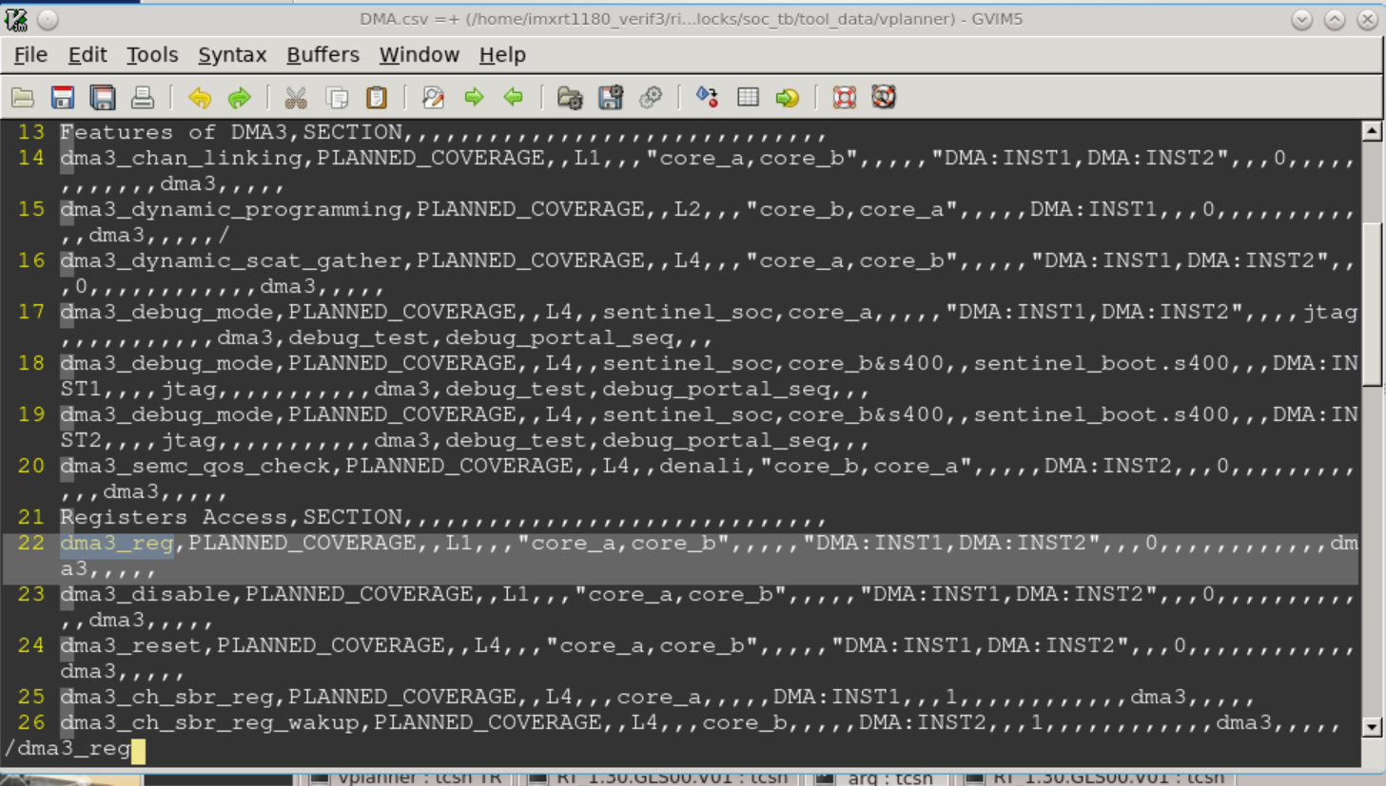

* 查看命令需要的-bc -tc参数，test case

/RT_1.29/testbench/blocks/soc_tb/tool_data/vplanner]$ openoffice DMA.csv

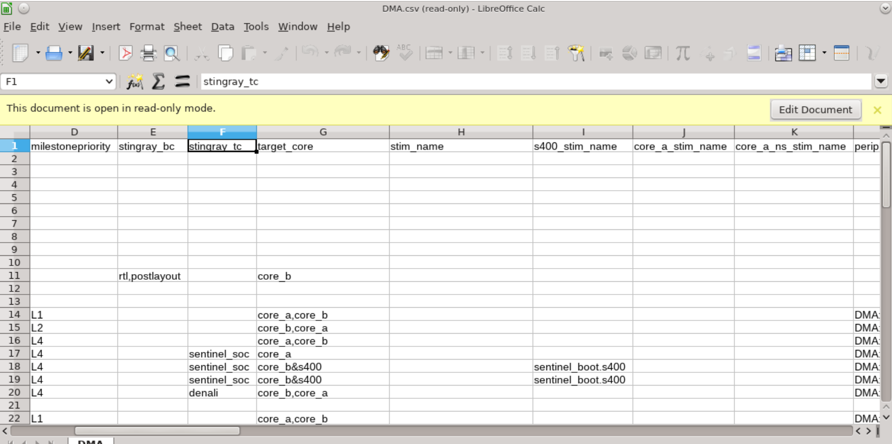

Test case名称从如下文件夹中获取

/home/imxrt1180_verif3/richard_nxa28190/RT_1.30.GLS00.V01/testbench/blocks/soc_tb/vectors/dma3/stimulus/arg

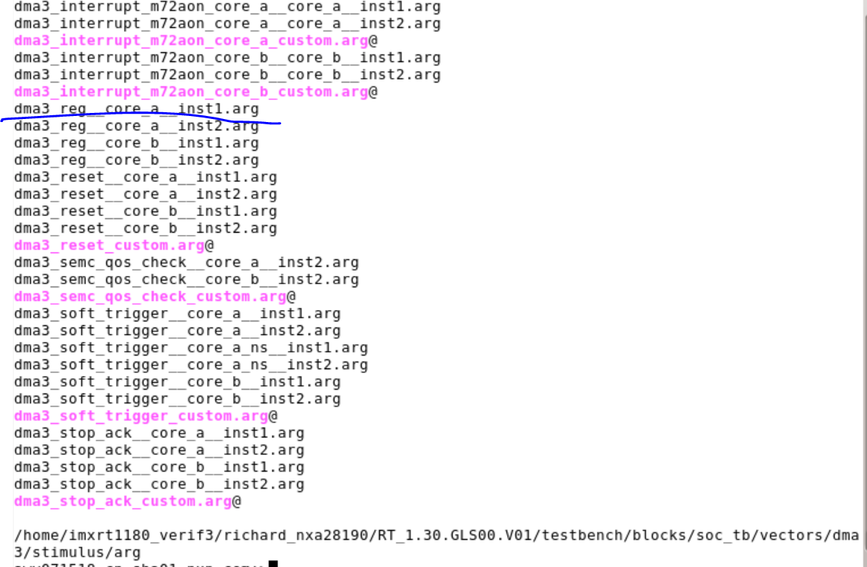

bsub -R rhel7 -q interq -Ip soc verilog -irun -block soc_tb -bc rtl -tc default -vectors sanity -test simple -shm -keeptemps -session default &

拼凑完成的command:

bsub -R rhel7 -q interq -Ip soc verilog -irun -block soc_tb -bc rtl -tc default -vectors dma3 -test dma3_reg__core_a__inst1 -shm -keeptemps -session default &

bsub -R rhel7 -q interq -Ip soc verilog -irun -block soc_tb -bc rtl -tc default -vectors dma3 -test dma3_interrupt_core_a_inst2_test_1 -shm -keeptemps -session default &

batchq -n 3

batchq_mt -n 8

-sim_arg “-gui”

-no_compile

* c文件

.arg文件里面指定用到的.c

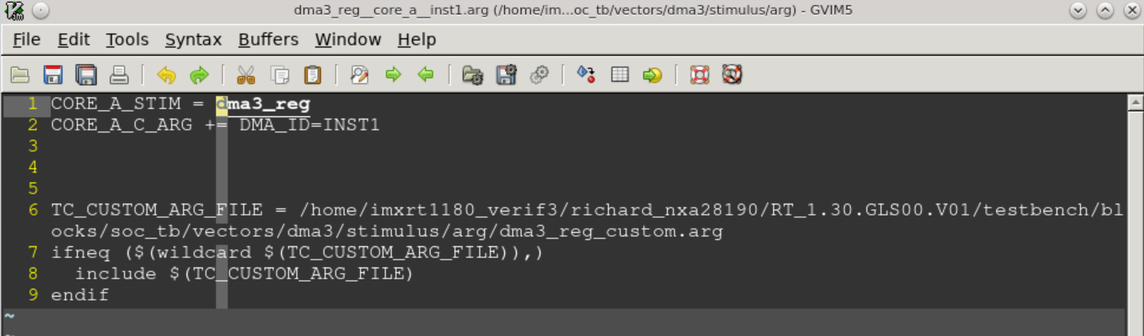

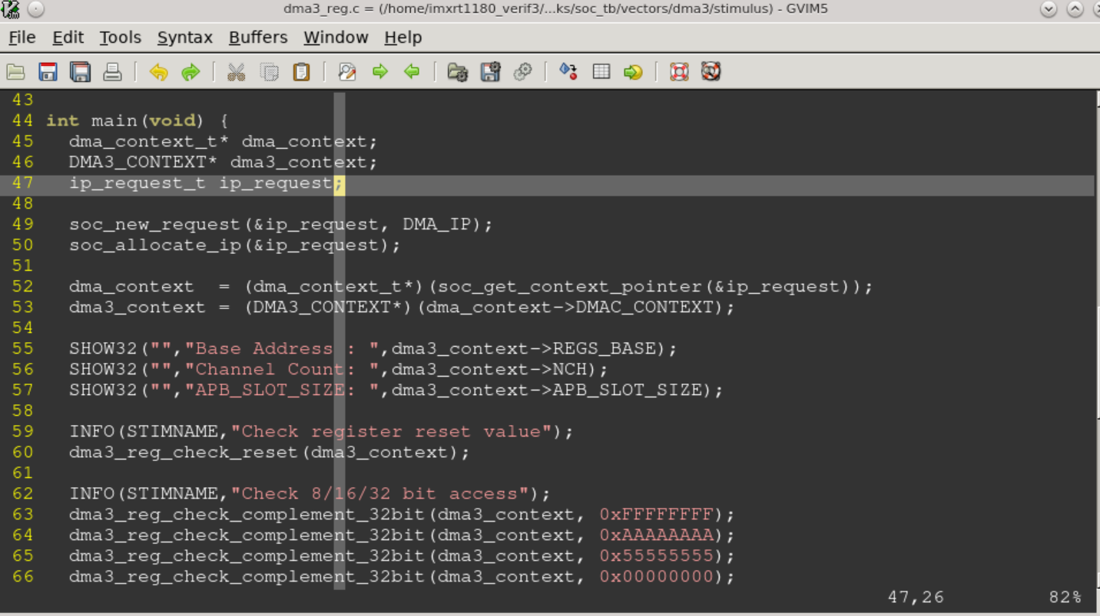

* 运行结束后，会生成logfile文件夹，result文件夹

Logfile文件夹中存放的test log以及测试命令，result文件夹中存放的事波形跟tarmac文件



## C查阅工具

/home/imxrt1180_verif3/richard_nxa28190/RT_1.30.GLS00.V01/testbench/blocks/soc_tb/vectors/dma3/stimulus/arg

tr.pkg OSS-sourcenavigator_NG-/4.5 snavigator &

## 常用文件

* Arg 文件

这里指定了需要编译的test case

/home/imxrt1180_verif3/richard_nxa28190/RT_1.30.GLS00.V01/testbench/blocks/soc_tb/vectors/dma3/stimulus/arg

* Test case .c文件

/home/imxrt1180_verif3/richard_nxa28190/RT_1.30.GLS00.V01/testbench/blocks/soc_tb/vectors/dma3/stimulus

* Test case 调用的common function， create_context_dma3函数的位置，对DMA的属性进行初始化

/home/imxrt1180_verif3/richard_nxa28190/RT_1.30.GLS00.V01/testbench/common_blocks/v_ms_spp_dma3_rt_vip/tool_data/compiler/include/



* DMA context ，API 定义, case里面在调用到create_context_dma3 之前的所有函数，变量都从这里找

/home/imxrt1180_verif3/richard_nxa28190/RT_1.30.GLS00.V01/testbench/blocks/soc_tb/tool_data/compiler/include

* NUM_DMA_INSTS DMA个数定义

testbench/blocks/soc_tb/tool_data/compiler/include

* ip_request->context_id = DMA_ID;

stimulus/arg文件中的定义DMA_ID会被传到这里，code根据DMA_ID的index，进行对应DMA的赋值。比如base_addr，channels等等

* ipc_dma##num##_assign() clock的定义，

需要clock的owner进行API的撰写，这里没有相关函数，编译会报错

* design 定义好的DMA的属性：

testbench/blocks/soc_tb/tool_data/sray/mem_map

testbench/blocks/soc_tb/tool_data/compiler/include

dma_context_t(cl) dma_context_t

testbench/blocks/soc_tb/tool_data/compiler/include/dma_context.h

DMA3_CONTEXT(cl) DMA3_CONTEXT testbench/common_blocks/v_ms_spp_dma3_rt_vip/tool_data/compiler/include/dma3.h

ip_request_t(cl) ip_request_t

testbench/blocks/soc_tb/tool_data/compiler/include/ip_request.h

DMA_IP \ soc_new_request \ soc_allocate_ip \ soc_get_context_pointer

testbench/blocks/soc_tb/tool_data/compiler/include/context_api.h

Mem_map.h中定义了DMA3寄存器的各类属性信息，包括DMA base addr， DMA的各类寄存器

* Map文件

/home/imxrt1180_verif3/richard_nxa28190/RT_1.30.GLS00.V01/testbench/blocks/soc_tb/tool_data/sray/mem_map

* Plan

/home/imxrt1180_verif3/richard_nxa28190/RT_1.30.GLS00.V01/testbench/blocks/soc_tb/tool_data/vplanner

* 编译C需要的头文件，environment.h之类

/home/imxrt1180_verif3/richard_nxa28190/RT_1.30.GLS00.V01/testbench/blocks/soc_tb/tool_data/compiler/include

testbench/blocks/soc_tb/tool_data/compiler/include/environment.h

* PP 文件

cd testbench/common_blocks/mcu_tb_utils/tool_data/compiler/

* 编译log

RT_1.30.GLS00.V01/testbench/blocks/soc_tb/tool_data/verilog/verilog_FILENAMES_apc7116.cn-sha01.nxp.com_7203

## 头文件关系

Environment.h

/home/imxrt1180_verif3/richard_nxa28190/RT_1.30.GLS00.V01/testbench/blocks/soc_tb/tool_data/compiler/include

# Code analysis

dma_context_t* dma_context;

DMA3_CONTEXT* dma3_context;

ip_request_t ip_request;

根据传入的IP的序列号，进行IP的初始化。DMA是0

soc_new_request(&ip_request, DMA_IP);

soc_allocate_ip(&ip_request);

获取DMA相关的内容

dma_context = (dma_context_t*)(soc_get_context_pointer(&ip_request));soc_get_context_pointer

dma3_context = (DMA3_CONTEXT*)(dma_context->DMAC_CONTEXT);

## soc_new_request

.\testbench\ blocks\soc_tb\tool_data\compiler\include\context_api.h

soc_new_request(fu) void (ip_request_t *,ip_type_e) testbench/blocks/soc_tb/tool_data/compiler/include/context_api.h

根据传入的IP 的ID，获取初始化函数

void soc_new_request(ip_request_t* ip_request, ip_type_e ip_type){

ip_request->ip_type = ip_type;

ip_request->init_context = NULL;

ip_request->clock_config = NULL;

ip_request->clock_disable = NULL;

ip_request->trig_config = NULL;

SHOW8("soc_new_request","requested ip_type enumeration number is: 0x", ip_type);

if(init_ip_request[ip_type])

init_ip_request[ip_type](ip_request);

else

FATAL("soc_new_request", "You need to define --> <CORE>_C_ARG += <BLOCK>_ID=X <-- in order to use this function");

}

### init_ip_request

.\testbench\ blocks\soc_tb\tool_data\compiler\include\context_api.h

init_ip_request_t init_ip_request[SUPPORTED_IP_TYPES_IN_SOC] = {

[DMA_IP] = dma_populate_request, //0

[BLK_CTRL_IP] = blk_ctrl_populate_request, //1

[MU_IP] = mu_populate_request, //2

[SEMA_IP] = sema_populate_request, //3

[TRDC_MGR_IP] = trdc_mgr_populate_request, //4

[TRDC_MC_IP] = trdc_mc_populate_request, //5

[SYSCTR_IP] = sysctr_populate_request, //6

[TSTMR_IP] = tstmr_populate_request, //7

[LPWDOG_IP] = lpwdog_populate_request, //8

[LPIT_IP] = lpit_populate_request, //9

[LPTMR_IP] = lptmr_populate_request, //10

[LPTPM_IP] = lptpm_populate_request, //11

[I3C_IP] = i3c_populate_request, //12

[LPI2C_IP] = lpi2c_populate_request, //13

[LPSPI_IP] = lpspi_populate_request, //14

[LPUART_IP] = lpuart_populate_request, //15

[FLEXCAN_IP] = flexcan3_populate_request, //16

[SAI_IP] = sai_populate_request, //17

[IPC_IP] = ipc_populate_request, //18

[M33_IP] = m33_populate_request, //19

[M33_SYSPM_IP] = m33_syspm_populate_request, //20

[M33_TCM_MECC_IP] = m33_tcm_mecc_populate_request, //21

[ROMCP_IP] = romcp_populate_request, //22

[BBNSM_IP] = bbnsm_populate_request, //23

[MTR_MSTR_IP] = mtr_mstr_populate_request, //24

[MTR_DCA_IP] = mtr_dca_populate_request, //25

[TCU_IP] = tcu_populate_request, //26

[BASIC_TROUT_IP] = basic_trout_populate_request, //27

[AXBS_IP] = axbs_populate_request, //65

[DCDC_IP] = dcdc_populate_request, //29

[FLEXSPI_IP] = flexspi_populate_request, //30

[XRIOCU_IP] = xriocu_populate_request, //31

[MOTOR_IP] = motor_populate_request, //32

[GPT_IP] = gpt_populate_request, //33

[FLEXIO_IP] = flexio_populate_request, //34

[ADC_IP] = adc_populate_request, //35

[FLEXPWM_IP] = flexpwm_populate_request, //36

[QTIMER_IP] = qtimer_populate_request, //37

[ENC_IP] = enc_populate_request, //38

[XBAR_IP] = xbar_populate_request, //39

[AOI_IP] = aoi_populate_request, //40

[EWM_IP] = ewm_populate_request, //41

[GPV_MEGA_IP] = gpv_mega_populate_request, //42

[USDHC_IP] = usdhc_populate_request, //43

[MSGINTR_IP] = msgintr_populate_request, //44

[XSPI_SLV_IP] = xspi_slv_populate_request, //45

[SEMC_IP] = semc_populate_request, //46

[OCRAM_MECC_IP] = ocram_mecc_populate_request, //47

[ASRC_IP] = asrc_populate_request, //48

[KPP_IP] = kpp_populate_request, //49

[ECAT_IP] = ecat_populate_request, //50

[SPDIF_IP] = spdif_populate_request, //51

[MICFIL_IP] = micfil_populate_request, //52

[SINC_IP] = sinc_populate_request, //53

[USB_IP] = usb_populate_request, //54

[USB_PHY_IP] = usb_phy_populate_request, //55

[ACMP_IP] = acmp_populate_request, //56

[DAC_IP] = dac_populate_request, //57

[VREF_IP] = vref_populate_request, //58

[IEE_IP] = iee_populate_request, //59

[SPTP_IP] = sptp_populate_request, //60

[SERDES_IP] = serdes_populate_request, //61

[SECSUBSYS_IP] = secsubsys_populate_request, //62

[NVIC_IP] = nvic_populate_request, //63

[LPCAC_IP] = lpcac_populate_request, //64

[NETC_IP] = netc_populate_request, //66

[XCEL_IP] = xcel_populate_request, //67

[GPIO_IP] = gpio_populate_request, //68

[SECSUBSYS_FSB_IP]= s400_fsb_populate_request, //69

[SEMA42_IP] = sema42_populate_request //70

};

### dma_populate_request

.\testbench\ blocks\soc_tb\tool_data\compiler\include\dma_contexti.h

#ifdef DMA_ID

void dma_populate_request(ip_request_t* ip_request){

ip_request->init_context = dma_init_context; dma_init_context

ip_request->context_id = DMA_ID;

}

#else

#define dma_populate_request NULL

#endif

## soc_allocate

soc_allocate_ip(fu) void (ip_request_t *) testbench/blocks/soc_tb/tool_data/compiler/include/context_api.h

调用soc_new_request获取的初始化函数，进行IP的初始化

void soc_allocate_ip(ip_request_t* ip_request){

if(!ip_request->init_context)

FATAL(CONTEXT_API_HEADER,"init_context function must be provided !!!");

ip_request->init_context(ip_request); dma_populate_request

if(ip_request->skip_configure)

return;

#ifndef SKIP_CLOCK_CFG

if(ip_request->clock_config)

ip_request->clock_config(ip_request);

#endif

#ifndef SKIP_RESET_CFG

if(ip_request->reset_negate)

ip_request->reset_negate(ip_request);

#endif

#ifndef SKIP_PIN_CFG

if(ip_request->pin_config)

ip_request->pin_config(ip_request);

#endif

#ifndef SKIP_TRIG_CFG

if(ip_request->trig_config)

ip_request->trig_config(ip_request);

#endif

// Interrupts

// Resource Allocation

}

void soc_allocate_ip(ip_request_t* ip_request){

if(!ip_request->init_context)

FATAL(CONTEXT_API_HEADER,"init_context function must be provided !!!");

ip_request->init_context(ip_request);

if(ip_request->clock_config)

ip_request->clock_config(ip_request);

if(ip_request->trig_config)

ip_request->trig_config(ip_request);

// Interrupts`

// Resource Allocation

}

### dma_init_context

.\testbench\ blocks\soc_tb\tool_data\compiler\include\dma_contexti.h

// ******************************************************************************************

// Function:

//

// Initialize and return context pointer associated with ip_request->context_id

// ******************************************************************************************

void dma_init_context(ip_request_t* ip_request){

dma_inst_id_e id = (dma_inst_id_e)ip_request->context_id;

create_context_dma_inst(id, (dma_context_t **)(&ip_request->context_ptr));

ip_request->clock_config = dma3_pcc_assign;

ip_request->clock_disable = dma3_pcc_release;

}

### create_context_dma_inst

.\testbench\ blocks\soc_tb\tool_data\compiler\include\dma_contexti.h

void create_context_dma_inst(dma_inst_id_e inst_num, dma_context_t** context){

static dma_context_t static_context;

DMA3_CONTEXT* dma3 = NULL;

create_context_dma3(inst_num, &dma3);

static_context.DMAC_CONTEXT = dma3;

static_context.DMA_MUX_CONTEXT = NULL;

static_context.LOGICAL_CHANNEL = -1;

static_context.PHYSICAL_CHANNEL = -1;

static_context.ALWAYS_EN = 0;

*context = &static_context;

}

### create_context_dma3

.\testbench\common_blocks\dma\ context_dma3.h

给DMA3_CONTEXT结构体进行赋值

#define CREATE_CONTEXT_DMA3_INST(num) \

void create_context_dma3_inst##num(DMA3_CONTEXT** context) \

{ static DMA3_CONTEXT static_context; \

static_context.NAME = "DMA3 INST" CAPI_STRINGIFY(num); \

static_context.REGS_BASE = DMA##num##_RBASE; \

static_context.TBCOMM_BASE = DMA##num##_TBCOMM_BASE; \

static_context.NCH = DMA##num##_CHANNELS; \

static_context.BUS_WIDTH = DMA##num##_BUS_WIDTH; \

static_context.INTERRUPT_VECTOR = DMA##num##_CH0_INT; \

static_context.TEA_INT_VECTOR = HARD_FAULT_XCP; \

static_context.interrupt_cnt = 0; \

static_context.tea_int_cnt = 0; \

static_context.err_int_cnt = 0; \

static_context.last_logged_error = 0; \

static_context.APB_SLOT_SIZE = DMA##num##_SLOT_SIZE; \

static_context.ENB_MID_REPL = DMA##num##_ENABLE_MID_REPL; \

static_context.ASW = DMA##num##_ASW; \

static_context.ENB_CH_BUFFWR = DMA##num##_ENB_CH_BUFFWR; \

static_context.ENB_MP_BUFFWR = DMA##num##_ENB_MP_BUFFWR; \

static_context.AHB_MASTER_ID = DMA##num##_AHB_MASTER_ID; \

static_context.COMBINED_IRQ = DMA##num##_COMBINED_IRQ; \

static_context.ENB_MP_INT = DMA##num##_ENB_MP_INT; \

static_context.NHR = DMA##num##_NHR; \

static_context.DMA_VERSION = DMA##num##_VERSION; \

static_context.DMA_ENB_SW_SECURITY_CTRL = DMA##num##_ENB_SW_SECURITY_CTRL; \

static_context.AHB_PAL_DEFAULT = DMA##num##_AHB_PAL_DEFAULT; \

static_context.AHB_SEC_DEFAULT = DMA##num##_AHB_SEC_DEFAULT; \

static_context.INUSE = 0; \

static_context.eop_enable = 0; \

*context = &static_context; \

}

PP_REPEAT(DMA_INSTS, CREATE_CONTEXT_DMA3_INST)

#define DMA_CREATE_CONTEXT_CASE(num) case DMA3_INST##num: create_context_dma3_inst##num(context); break;

void create_context_dma3(dma_inst_id_e inst_num, DMA3_CONTEXT** context)

{

switch (inst_num){

PP_REPEAT(DMA_INSTS, DMA_CREATE_CONTEXT_CASE)

default:

SHOW8(CONTEXT_DMA3_HEADER,"DMA_INST: ", (int)inst_num);

FATAL(CONTEXT_DMA3_HEADER,"DMA DOES NOT EXIST");

}

}

#### PP_REPEAT如何获取IP属性

DMA为例：

1. CREATE_CONTEXT_DMA3_INST 函数中会给DMA3_CONTEXT进行赋值，传参是DMA的inst

static_context.REGS_BASE = DMA##num##_RBASE;

1. 如果如上num为1则dma3_context->REGS_BASE赋值为 DMA1_RBASE
2. /testbench/blocks/soc_tb/tool_data/sray/mem_map/dma_params.mem_map:71:`define DMA1_RBASE `EDMA1_CH0_RBASE
3. /testbench/blocks/soc_tb/tool_data/sray/mem_map/aips_cm33_sec.mem_map:282:`define EDMA1_CH0_RBASE `CM33_EDMA1_CH0_RBASE // AIPS1 slot 0
4. ./testbench/blocks/soc_tb/tool_data/sray/mem_map/aips_cm33_sec.mem_map:5:`define CM33_EDMA1_CH0_RBASE 'h54000000 // AIPS1 slot 0

DMA register定义：

.\testbench\common_blocks\dma\ dma3.h

DMA3_CONTEXT的赋值函数在.\testbench\common_blocks\dma\ context_dma3.h

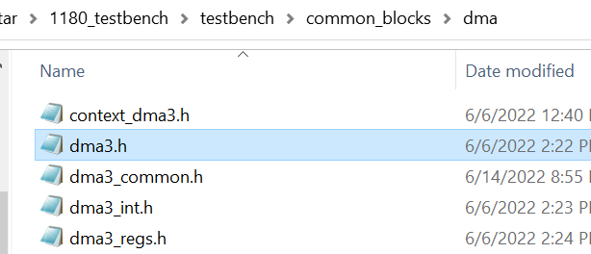

DMA register base addr, auto generated from xlsx file

./testbench/blocks/soc_tb/tool_data/sray/mem_map/aips_cm33_sec.mem_map

## soc_get_context_pointer

IP初始化成功后，就可以获取IP相关的属性参数。

//Function to get the pointer to the context

void* soc_get_context_pointer(ip_request_t* ip_request)

{

return ip_request->context_ptr;

}

dma_context = (dma_context_t*)(soc_get_context_pointer(&ip_request));

dma3_context = (DMA3_CONTEXT*)(dma_context->DMAC_CONTEXT);

SHOW32("","Base Address : ",dma3_context->REGS_BASE);

SHOW32("","Channel Count: ",dma3_context->NCH);

SHOW32("","APB_SLOT_SIZE: ",dma3_context->APB_SLOT_SIZE);

### ip_request_t

testbench/blocks/soc_tb/tool_data/compiler/include/ip_request.h

// This is a SoC specific function. Future implementations may need to initialize more elements

typedef struct ip_request_t ip_request_t;

struct ip_request_t{

ip_type_e ip_type;

int context_id;

void* context_ptr;

pinmux_alt_e pinmux_opt;

uint8_t skip_configure;

void (*init_context)(ip_request_t* ip_request);

void (*clock_config)(ip_request_t* ip_request);

void (*clock_disable)(ip_request_t* ip_request);

void (*pin_config)(ip_request_t* ip_request);

void (*pin_disable)(ip_request_t* ip_request);

void (*trig_config)(ip_request_t* ip_request);

void (*reset_assert)(ip_request_t* ip_request);

void (*reset_negate)(ip_request_t* ip_request);

};

#endif

### dma_context_t

/home/imxrt1180_verif3/richard_nxa28190/RT_1.30.GLS00.V01/testbench/blocks/soc_tb/tool_data/compiler/include/ dma_context.h

//------------------------------------------------------------------------------

// SoC-specific DMA Controller Context

// -----------------------------------------------------------------------------

typedef struct

{ void* DMAC_CONTEXT;

void* DMA_MUX_CONTEXT;

uint8_t LOGICAL_CHANNEL;

uint8_t PHYSICAL_CHANNEL;

uint8_t ALWAYS_EN;

} dma_context_t;

### DMA3_CONTEXT

/home/imxrt1180_verif3/richard_nxa28190/RT_1.30.GLS00.V01/testbench/common_blocks/v_ms_spp_dma3_rt_vip/tool_data/compiler/include/dma3.h

// DMA3 Context struct

// Note: Variables in ALL_CAPS are for the SoC team to fill in before calling

// any of the functions, and should be considered constants.

// Variables in lower_case are private variables for the functions to use.

typedef struct {

char* NAME;

// ===============Parameter Info of IP================

uint8_t NCH;

uint8_t BUS_WIDTH;

vuint8_t ENB_MID_REPL;

vuint8_t ASW;

vuint8_t ENB_CH_BUFFWR;

vuint8_t ENB_MP_BUFFWR;

vuint8_t AHB_MASTER_ID;

vuint8_t COMBINED_IRQ;

vuint8_t ENB_MP_INT;

vuint8_t NHR;

vuint8_t DMA_VERSION;

vuint8_t DMA_ENB_SW_SECURITY_CTRL;

vuint8_t AHB_PAL_DEFAULT;

vuint8_t AHB_SEC_DEFAULT;

// ===============BASE Info===========================

address_t REGS_BASE;

uint32_t APB_SLOT_SIZE;

tbcomm_t TBCOMM_BASE;

// ===============Interrupt===========================

vector_t INTERRUPT_VECTOR;

vector_t TEA_INT_VECTOR;

vector_t ERROR_INTERRUPT_VECTOR;

vuint8_t interrupt_cnt;

vuint8_t tea_int_cnt;

vuint8_t err_int_cnt;

vuint32_t last_logged_error;

// ==================DMA==============================

uint32_t INUSE;

vuint8_t eop_enable;

} DMA3_CONTEXT;

## dma3_reg_check_reset

// TCD reset values are not tested, due to they are from sram

void dma3_reg_check_reset(DMA3_CONTEXT* dma3_context)

{

uint32_t channel, sbr_reset_val;

sbr_reset_val = (dma3_context->DMA_ENB_SW_SECURITY_CTRL)? ((dma3_context->AHB_PAL_DEFAULT<<15)|(dma3_context->AHB_SEC_DEFAULT<<14)|dma3_context->AHB_MASTER_ID):((dma3_context->AHB_PAL_DEFAULT<<15)|dma3_context->AHB_MASTER_ID);

SHOW32("sbr_reset_val is", " 0x", sbr_reset_val);

INFO("Start of ", "Checking reset register values");

RE32(REG32(DMA3_MP_CSR),DMA3_MP_CSR_RESET |(dma3_context->DMA_VERSION <<16));

RE32(REG32(DMA3_MP_ES),DMA3_MP_ES_RESET);

if (dma3_context->ENB_MP_INT) {

RE32(REG32(DMA3_MP_INT), DMA3_MP_INT_RESET);

}

if(DMA_ID==INST1)

RE32(REG32(DMA3_MP_HRS),DMA3_MP_HRS_RESET);//the INST2'S HRS is reserved;

SHOW8("DMA CHANNEL count is ", " 0x", dma3_context->NCH);

for (channel=0; channel<dma3_context->NCH; channel++)

RE32(DMA3_GRPRI(channel), DMA3_CH_GRPRI_RESET);

for (channel=0; channel<dma3_context->NCH; channel++)

{

SHOW8("DMA3 CHANNEL index is ", " 0x", channel);

RE32(DMA3_CH_CSR(channel), DMA3_CH_CSR_RESET);

RE32(DMA3_CH_ES(channel), DMA3_CH_ES_RESET);

RE32(DMA3_CH_INT(channel), DMA3_CH_INT_RESET);

RE32(DMA3_CH_SBR(channel), sbr_reset_val);

RE32(DMA3_CH_PRI(channel), DMA3_CH_PRI_RESET);

if (dma3_context->NHR>dma3_context->NCH) {

RE32(DMA3_CH_MUX(channel), DMA3_CH_MUX_RESET);

}

}

}

### RE32

//============================================================================

// Read & Compare - 32 bits

// Read a value from address and print an error message if the value read

// does not match expected_data. Otherwise, print the read operation.

//============================================================================

void CAPI_Base::RE32 (U32 address, U32 expected_data)

{

U32 destvar;

isr_escape();

stdtsk_quiet++; // suppress messages from base function

R32(address, destvar);

stdtsk_quiet--;

if (destvar == expected_data)

{

print_portable_task_msg("RE32", address, DONT_CARE_Z, (U64)stdtsk_read_value,

(U64)expected_data, DONT_CARE_Z, STDTSK_SZ_32,

stdtsk_current_function_code,

(STDTSK_SUCCESS | STDTSK_PRNT_READ | STDTSK_PRNT_EXP));

}

else

{

print_portable_task_msg("RE32", address, DONT_CARE_Z, (U64)stdtsk_read_value,

(U64)expected_data, DONT_CARE_Z, STDTSK_SZ_32,

stdtsk_current_function_code,

(STDTSK_FAIL | STDTSK_PRNT_READ | STDTSK_PRNT_EXP));

}

}

## dma3_reg_check_complement_32bit

dma3_reg_check_complement_8bit(fu) void (DMA3_CONTEXT *,uint16_t) testbench/common_blocks/v_ms_spp_dma3_rt_vip/tool_data/compiler/include/dma3_regs.h

// Method used for checking DMA registers R/W by 32bit access

void dma3_reg_check_complement_32bit(DMA3_CONTEXT* dma3_context,uint32_t wr_val)

{

uint8_t channel;

INFO("Start of ", "Checking rw register values 32 bit access");

WRE32(REG32(DMA3_MP_CSR),wr_val,(wr_val & (DMA3_MP_CSR_MASK | dma3_context->ENB_MP_BUFFWR))|(dma3_context->DMA_VERSION <<16));

WRE32(REG32(DMA3_MP_ES),wr_val,wr_val & DMA3_MP_ES_MASK);

if (dma3_context->ENB_MP_INT) {

WRE32(REG32(DMA3_MP_INT),wr_val,0x00000000);

}

if(DMA_ID==INST1)

WRE32(REG32(DMA3_MP_HRS),wr_val,wr_val & DMA3_MP_HRS_MASK);

SHOW8("DMA CHANNEL count is ", " 0x", dma3_context->NCH);

for (channel=0; channel<dma3_context->NCH; channel++)

if(DMA_ID==INST1)

WRE32(DMA3_GRPRI(channel), wr_val, wr_val & DMA3_CH_GRPRI_MASK);

else

WRE32(DMA3_GRPRI(channel), wr_val, wr_val & 0x3f);//this is because the dma4 has six bit

for (channel=0; channel<dma3_context->NCH; channel++)

{

SHOW8("DMA3 CHANNEL index is ", " 0x", channel);

if(DMA_ID==INST1)

WRE32(DMA3_CH_CSR(channel), wr_val, wr_val & (DMA3_CH_CSR_MASK | dma3_context->ENB_CH_BUFFWR<<3));

else{

SHOW8("channel for debug ", " 0x", channel);

WRE32(DMA3_CH_CSR(channel), wr_val, wr_val & DMA3_CH_CSR_MASK_INST2);

}

WRE32(DMA3_CH_ES(channel), wr_val, wr_val & DMA3_CH_ES_MASK);

WRE32(DMA3_CH_INT(channel), wr_val, wr_val & DMA3_CH_INT_MASK);

WRE32(DMA3_CH_PRI(channel), wr_val, wr_val & DMA3_CH_PRI_MASK);

if (dma3_context->NHR>dma3_context->NCH) {

WRE32(DMA3_CH_MUX(channel), dma3_context->NHR-1 , dma3_context->NHR-1);

WRE32(DMA3_CH_MUX(channel), 0, 0);

}

WRE32(DMA3_TCD_SADDR(channel), wr_val, wr_val & DMA3_TCD_SADDR_SADDR_MASK);

WRE32(DMA3_TCD_SOFF(channel), wr_val, wr_val &((DMA3_TCD_ATTR_MASK<<16)|(DMA3_TCD_SOFF_SOFF_MASK)));

WRE32(DMA3_TCD_NBYTES(channel), wr_val, wr_val & DMA3_TCD_NBYTES_MASK);

WRE32(DMA3_TCD_SLAST(channel), wr_val, wr_val & DMA3_TCD_SLAST_MASK);

WRE32(DMA3_TCD_DADDR(channel), wr_val, wr_val & DMA3_TCD_DADDR_DADDR_MASK);

WRE32(DMA3_TCD_DOFF(channel), wr_val, wr_val &((DMA3_TCD_CITER_MASK<<16)|(DMA3_TCD_DOFF_DOFF_MASK)));

WRE32(DMA3_TCD_DLAST(channel), wr_val, wr_val & DMA3_TCD_DLAST_DLAST_MASK);

WRE32(DMA3_TCD_CSR(channel), wr_val & 0xFFFFFFFE, wr_val & 0xFFFFFFFE &((DMA3_TCD_BITER_MASK<<16)|(DMA3_TCD_CSR_MASK)));

}

}

### WRE32

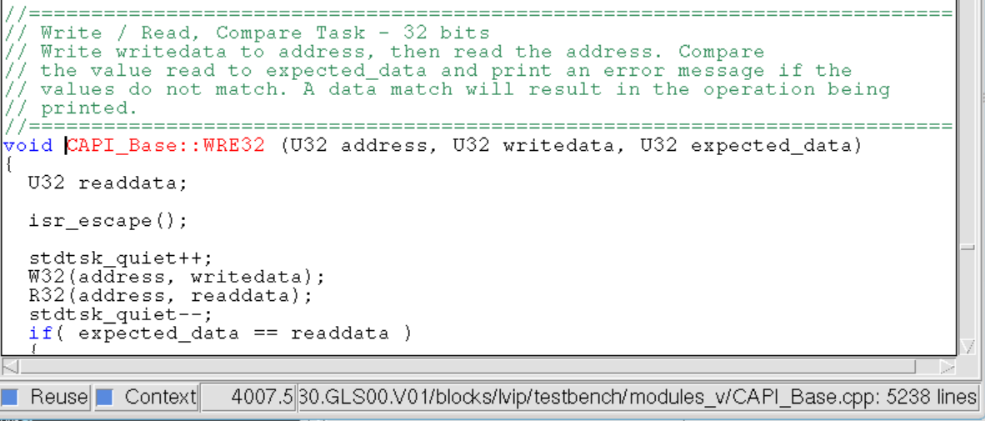

## Register

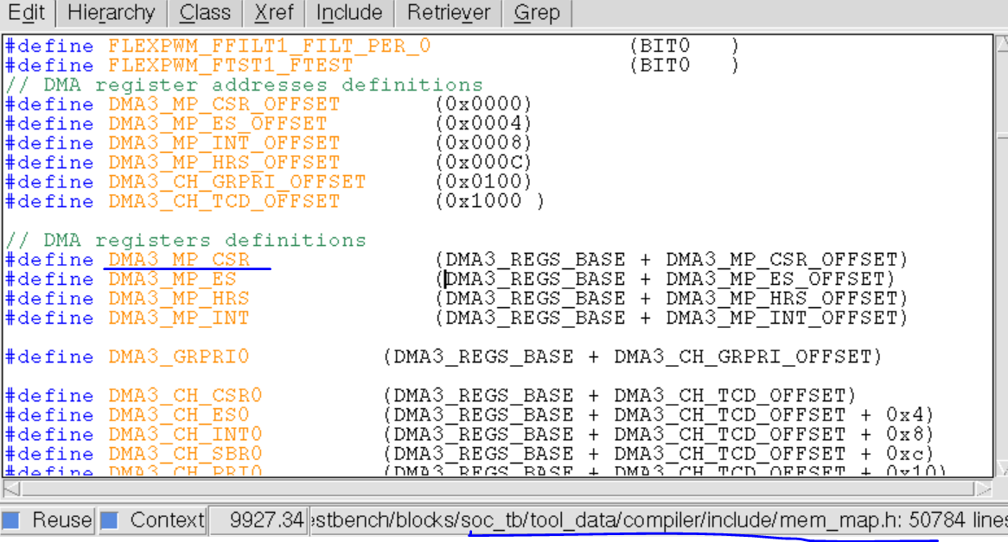

## 中断工作流程

### dma3_setup_int(dma3_context);

配置中断服务函数

#### dma3_int_isr

//DMA3 interrupt service routine

void dma3_int_isr(DMA3_CONTEXT* dma3_context) {

uint32_t channel_status, channel_csr;

uint32_t channel_tcd_csr;

uint8_t channel_index;

// Clear interrupt

R32(REG32(DMA3_MP_CSR), channel_status);

channel_index = (channel_status&DMA3_MP_CSR_CHID_MASK)>>24;

SHOW8(dma3_context->NAME, "dma3_int_isr: severed channel: 0x", channel_index);

R32(DMA3_CH_CSR(channel_index), channel_csr);

if(channel_csr&DMA3_CH_CSR_DONE_MASK)

{

BSET32(DMA3_CH_CSR(channel_index),DMA3_CH_CSR_DONE_MASK);

BSET32(DMA3_CH_INT(channel_index),DMA3_CH_INT_INT_MASK);

++(dma3_context->interrupt_cnt);

INFO(dma3_context->NAME, "dma3_int_isr: dma done interrupt serviced");

} else {

R32(DMA3_TCD_CSR(channel_index), channel_tcd_csr);

if(channel_tcd_csr&DMA3_TCD_CSR_INTHALF_MASK)

{

BSET32(DMA3_CH_INT(channel_index),DMA3_CH_INT_INT_MASK);

++(dma3_context->interrupt_cnt);

INFO(dma3_context->NAME, "dma3_int_isr: dma half done interrupt serviced");

}

}

} // dma3_int_isr

### dma3_setup_hw

dma3_setup_hw(dma3_context,i,(address_t)source, (address_t)dest,4,4,4,4,16,2);

void dma3_setup_hw(DMA3_CONTEXT* dma3_context,

uint8_t channel,

uint32_t source,

uint32_t destination,

uint8_t source_size, //4

uint8_t destination_size, //4

int16_t source_offset, //4

int16_t destination_offset //4,

uint32_t bytes_per_transfer, //16

uint16_t iterations) //2

{

//fix setup_hw with fixed ID, remote read/write

uint32_t proc_id = 0;

uint32_t local_read = 0;

uint32_t local_write = 0;

dma3_setup_complex(dma3_context, // context

channel, // channel

source , // source

0, // source_modulo

source_size, // source_size

0, // destination_modulo

destination_size, // destination_size

source_offset, // source_offset

bytes_per_transfer, // bytes_per_transfer

0, // source_adjustment

destination, // destination

0, // link

0, // link_channel

iterations, // iterations

destination_offset, // destination_offset

0, // destination_adjustment

0x0008|(dma3_context->eop_enable<<6), // control status - d_req = 1 - disable HW request once iterations are complete

local_read,

local_write,

proc_id); //process id to use

}

#### dma3_setup_complex

配置channel寄存器

void dma3_setup_complex(DMA3_CONTEXT* dma3_context,

uint8_t channel,

uint32_t source,

uint8_t source_modulo,

uint8_t source_size, // bytes

uint8_t destination_modulo,

uint8_t destination_size, // bytes

int16_t source_offset,

uint32_t bytes_per_transfer,

uint32_t source_adjustment,

uint32_t destination,

uint8_t link,

uint8_t link_channel,

uint16_t iterations,

int16_t destination_offset,

uint32_t destination_adjustment,

int16_t control_status,

uint32_t local_read,

uint32_t local_write,

uint32_t proc_id)

{

// Word 0/1

WR32(DMA3_TCD_SADDR (channel), source);

WR16(DMA3_TCD_ATTR (channel), (source_modulo << 11) | ssize | (destination_modulo << 3) | dsize);

WR16(DMA3_TCD_SOFF (channel), source_offset);

// Word 2/3

WR32(DMA3_TCD_NBYTES(channel), bytes_per_transfer);

WR32(DMA3_TCD_SLAST (channel), source_adjustment);

// Word 4/5

WR32(DMA3_TCD_DADDR(channel), destination);

WR16(DMA3_TCD_CITER(channel), (link << 15) | (link_channel << 9) | iterations);

WR16(DMA3_TCD_DOFF (channel), destination_offset);

// Word 6/7

WR32(DMA3_TCD_DLAST(channel), destination_adjustment);

WR16(DMA3_TCD_BITER(channel), (link << 15) | (link_channel << 9) | iterations);

WR16(DMA3_TCD_CSR (channel), control_status);

WRM32(DMA3_CH_SBR(channel), (local_read<<22)|(local_write<<21)|((proc_id&0xF)<<17), (local_read<<22)|(local_write<<21)|((proc_id&0xF)<<17) );

WRE32(DMA3_CH_CSR(channel), DMA3_CH_CSR_DONE_MASK|DMA3_CH_CSR_ERQ_MASK|DMA3_CH_CSR_EARQ_MASK|DMA3_CH_CSR_EEI_MASK, DMA3_CH_CSR_ERQ_MASK|DMA3_CH_CSR_EARQ_MASK|DMA3_CH_CSR_EEI_MASK);

// Send Channel and iterations to sv to do dma trans checking

MB_PUT16(DMA3_ITERATIONS_MBOX, iterations);

# Register definition

### DMA3_TCD_SADDR

WR32(DMA3_TCD_SADDR (channel), source);

数据的源地址写入此寄存器

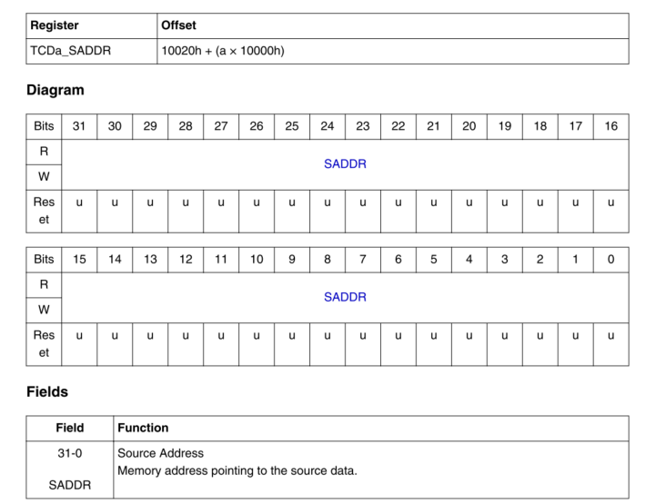

### DMA3_TCD_SOFF

相对于源地址的偏移量

WR16(DMA3_TCD_SOFF (channel), source_offset); //4

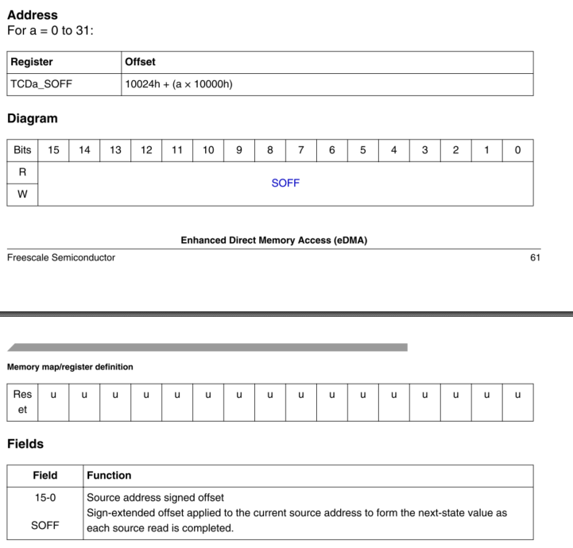

### DMA3_TCD_ATTR

WR16(DMA3_TCD_ATTR (channel), (source_modulo << 11) | ssize | (destination_modulo << 3) | dsize);

0<<11 | 0x200 | 0<<3 | 0x2 source /destination size transfer : 16bytes

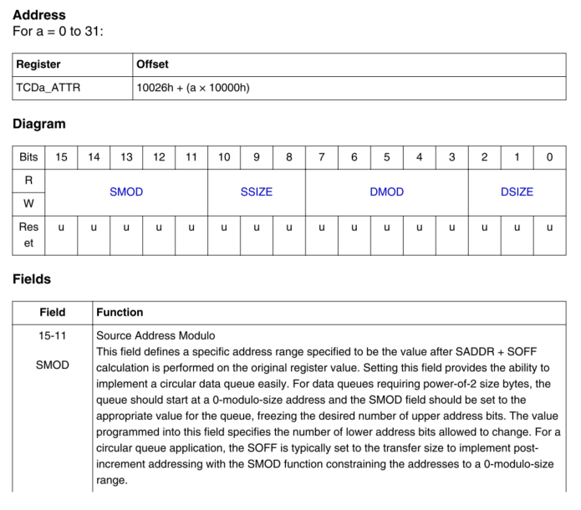

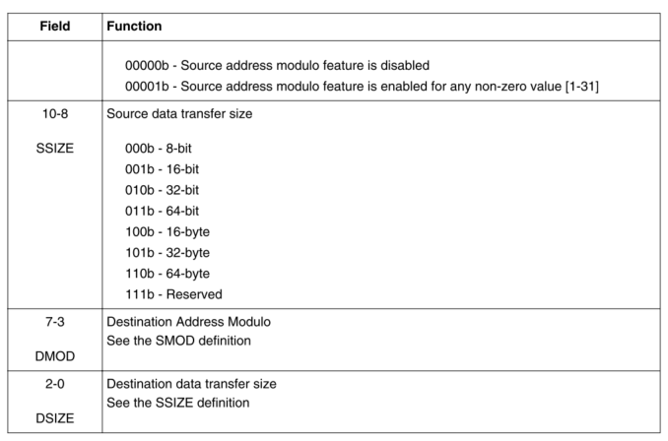

### DMA3_TCD_NBYTES

WR32(DMA3_TCD_NBYTES(channel), bytes_per_transfer); //16 Nbytes表示channel每次传输的字节数

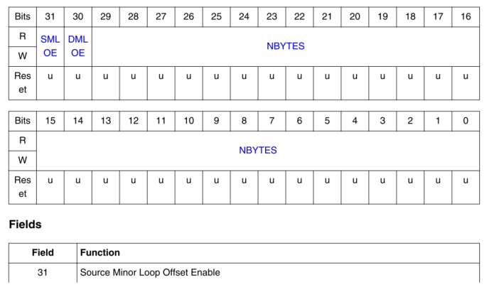

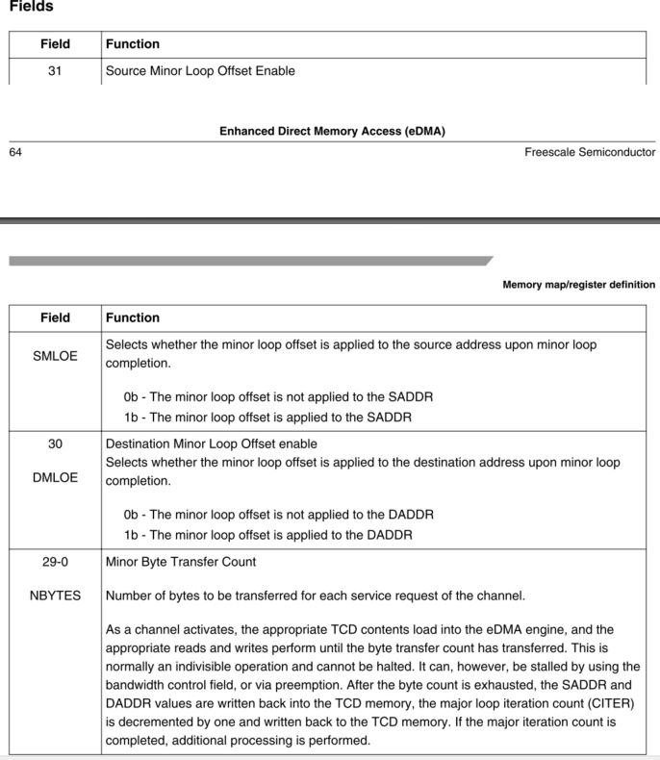

### DMA3_TCD_SLAST

WR32(DMA3_TCD_SLAST (channel), source_adjustment); //0

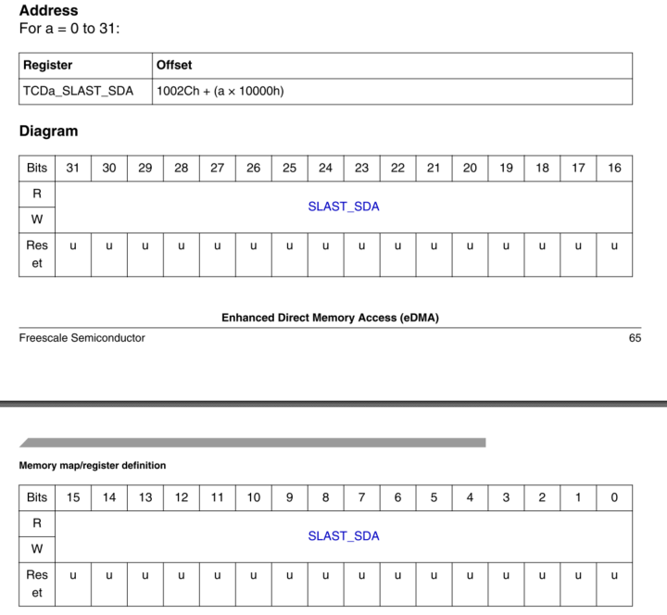

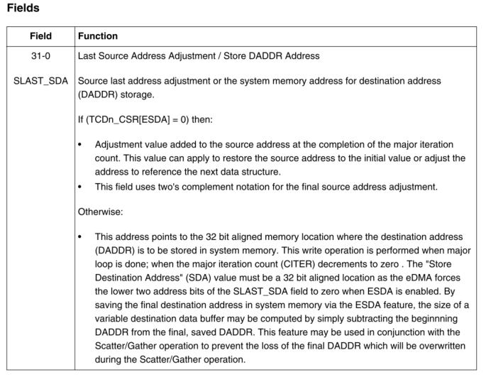

### DMA3_TCD_DADDR

WR32(DMA3_TCD_DADDR(channel), destination);

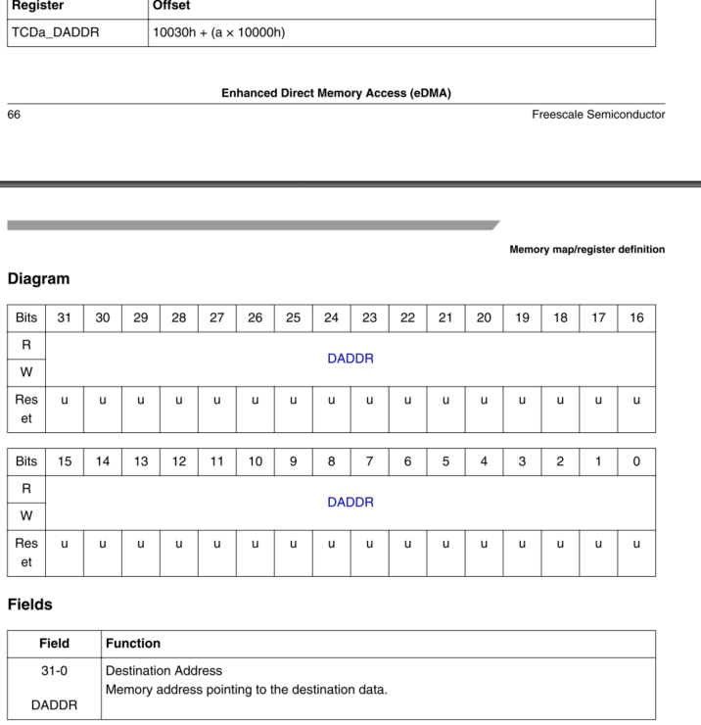

### DMA3_TCD_CITER

WR16(DMA3_TCD_CITER(channel), (link << 15) | (link_channel << 9) | iterations);

Interatios表示该channel 的major Loop次数

0<15|0<<9|2

如果bit15 ELINK=1，bit[13:9]当作LINKCH使用。

如果bit15 ELINK=0, bit[14:0]当作CITER使用

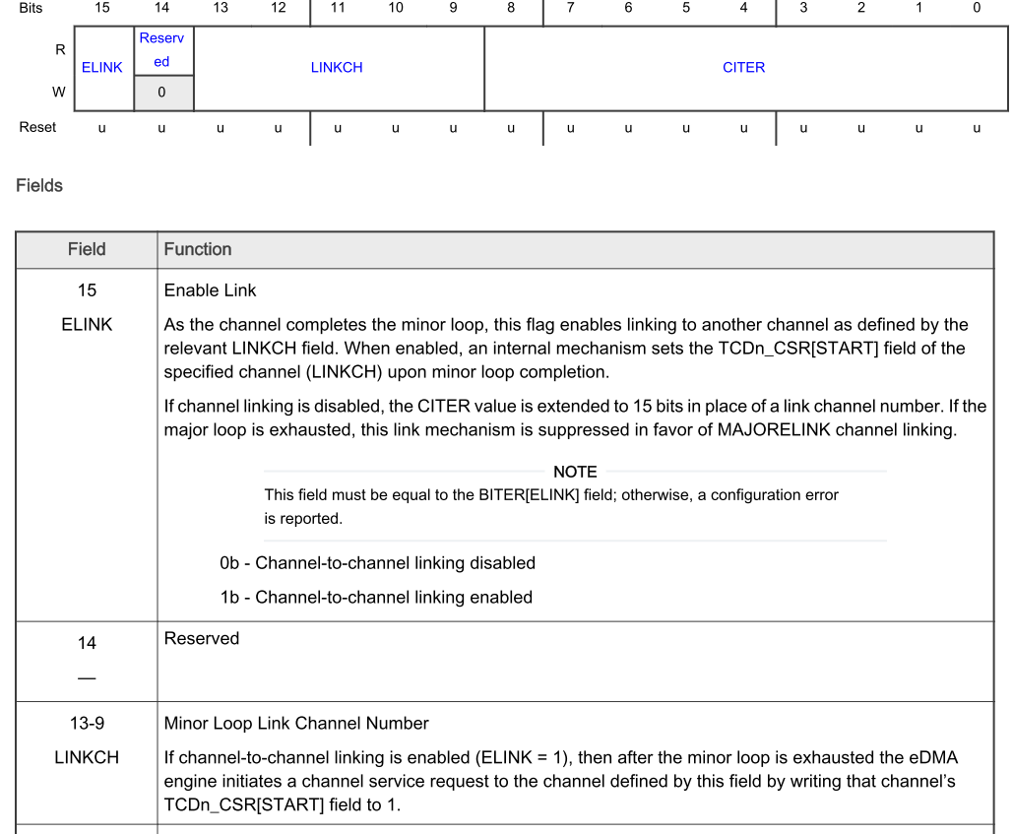

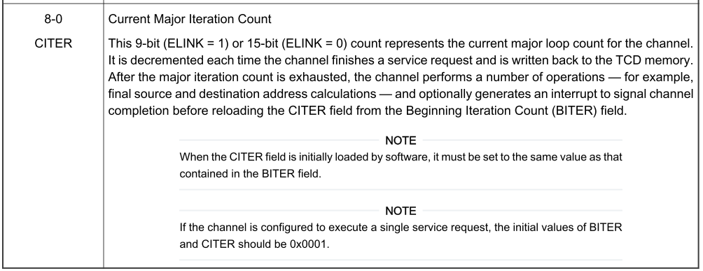

### DMA3_TCD_DOFF

WR16(DMA3_TCD_DOFF (channel), destination_offset); //4

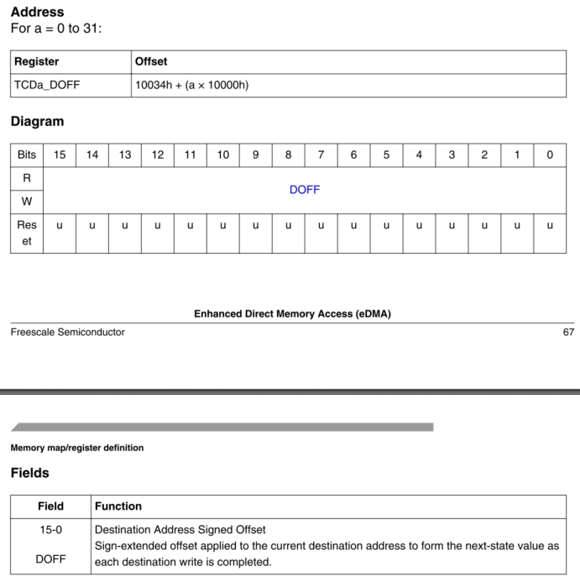

### DMA3_TCD_DLAST

**WR32(DMA3_TCD_DLAST(channel), destination_adjustment); //0**

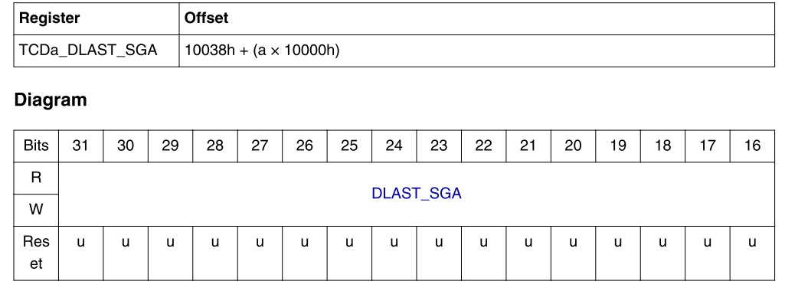

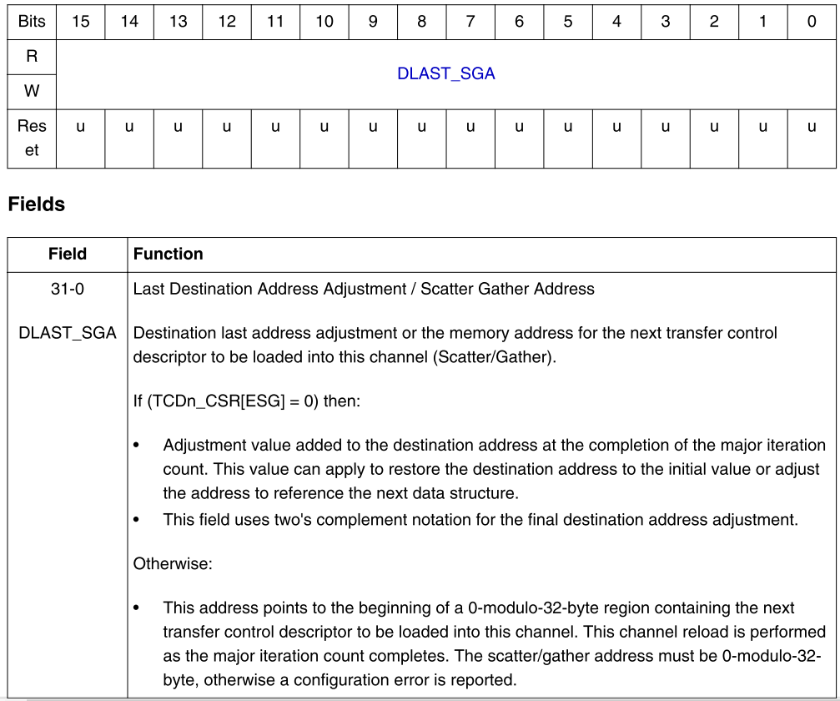

### DMA3_TCD_BITER

**WR16(DMA3_TCD_BITER(channel), (link << 15) | (link_channel << 9) | iterations);**

**0<<15|0<<9|2**

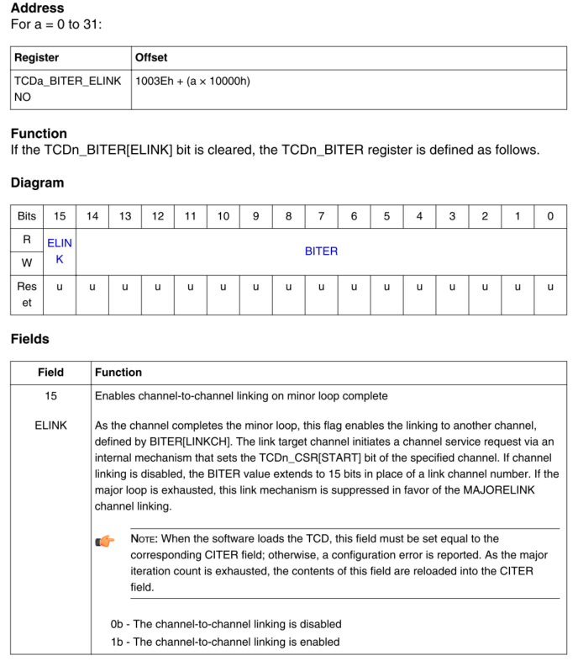

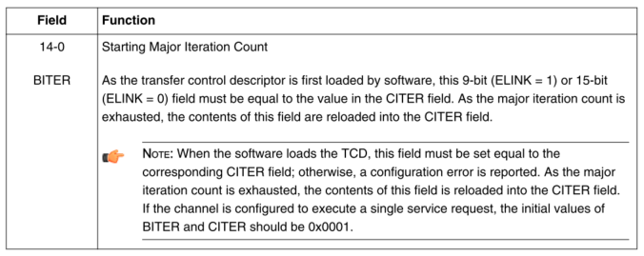

### DMA3_TCD_CSR

**WR16(DMA3_TCD_CSR (channel), control_status);**

0x0008|(dma3_context->eop_enable<<6),

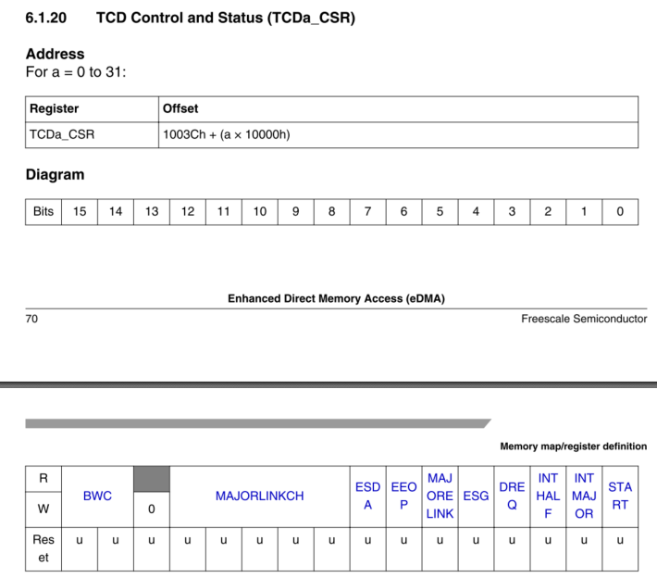

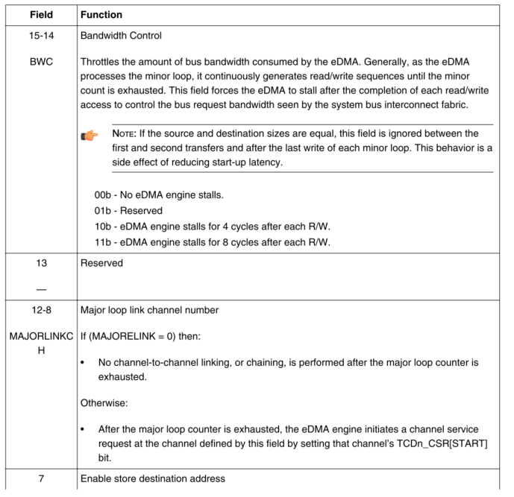

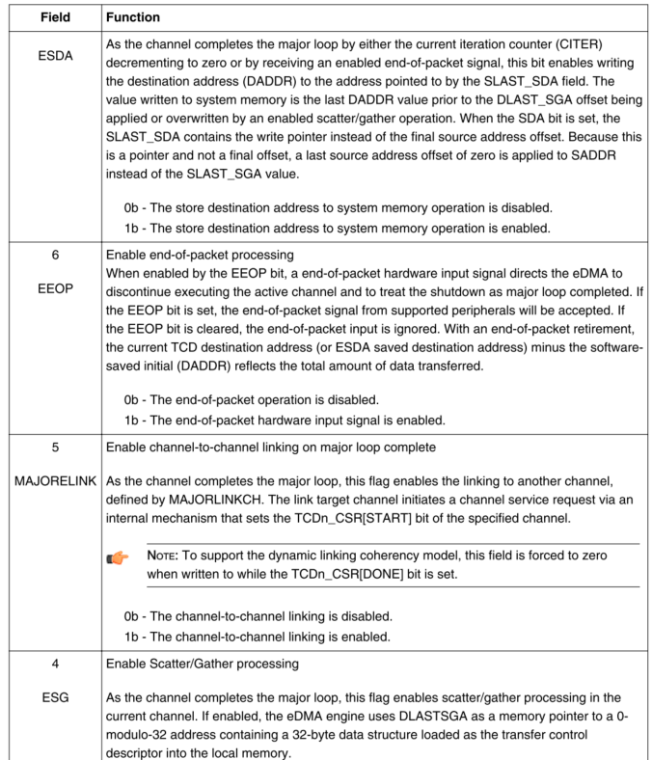

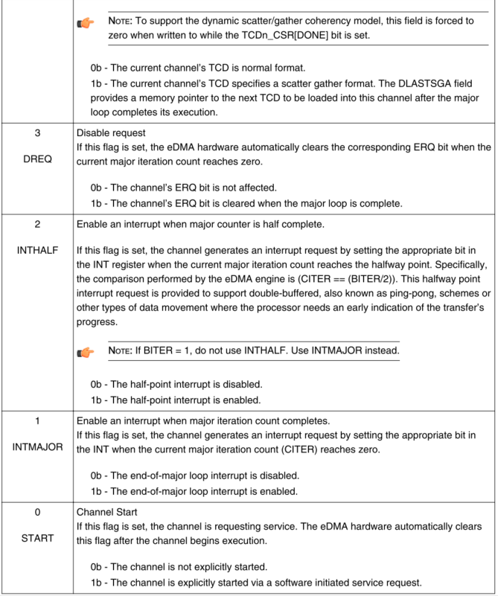

### DMA3_CH_SBR

**WRM32(DMA3_CH_SBR(channel), (local_read<<22)|(local_write<<21)|((proc_id&0xF)<<17), (local_read<<22)|(local_write<<21)|((proc_id&0xF)<<17) );**

**0**

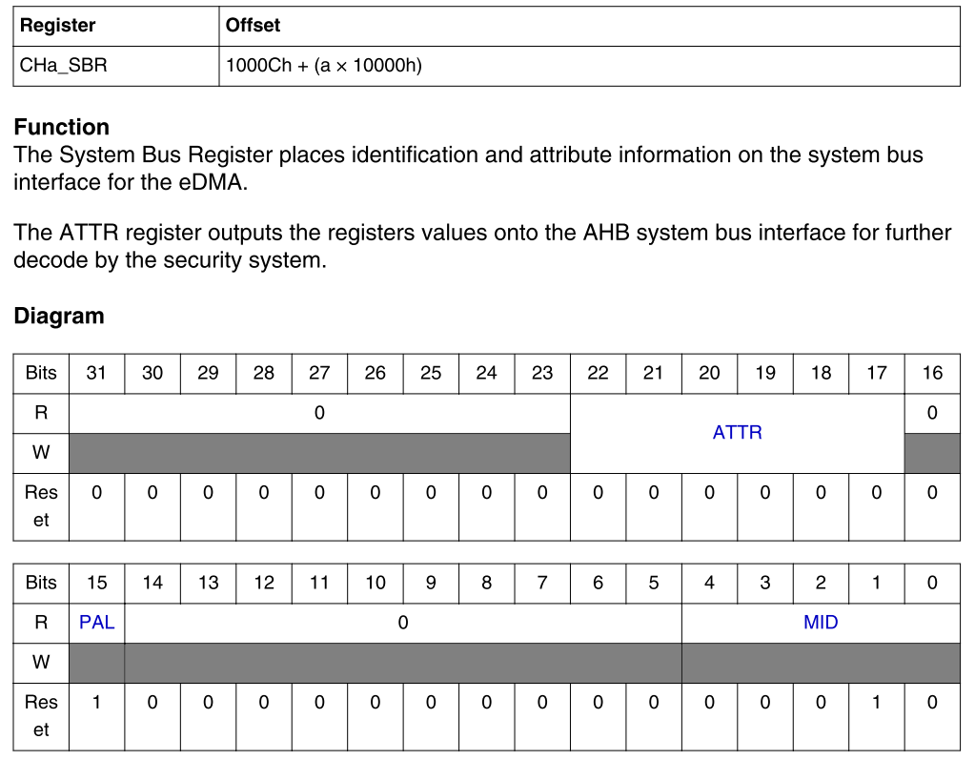

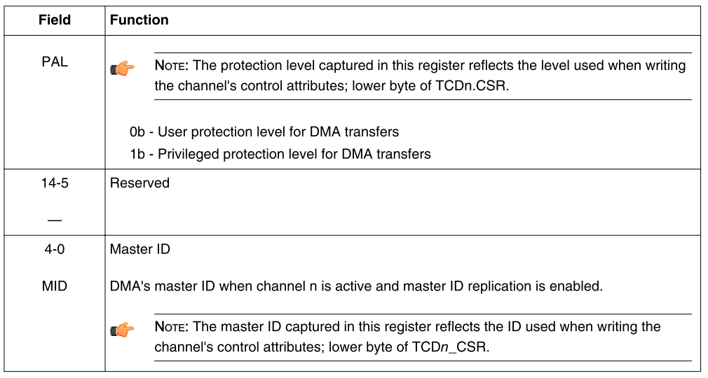

### DMA3_CH_CSR

**WRE32(DMA3_CH_CSR(channel), DMA3_CH_CSR_DONE_MASK|DMA3_CH_CSR_ERQ_MASK|DMA3_CH_CSR_EARQ_MASK|DMA3_CH_CSR_EEI_MASK, DMA3_CH_CSR_ERQ_MASK|DMA3_CH_CSR_EARQ_MASK|DMA3_CH_CSR_EEI_MASK);**

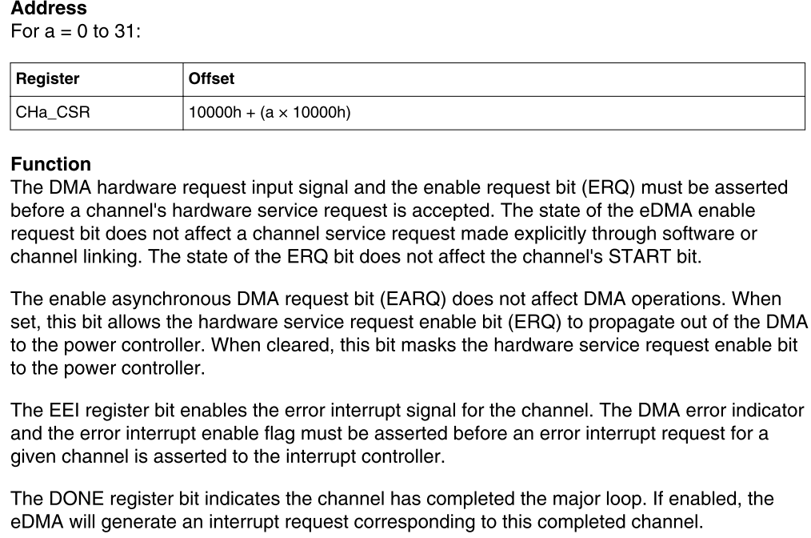

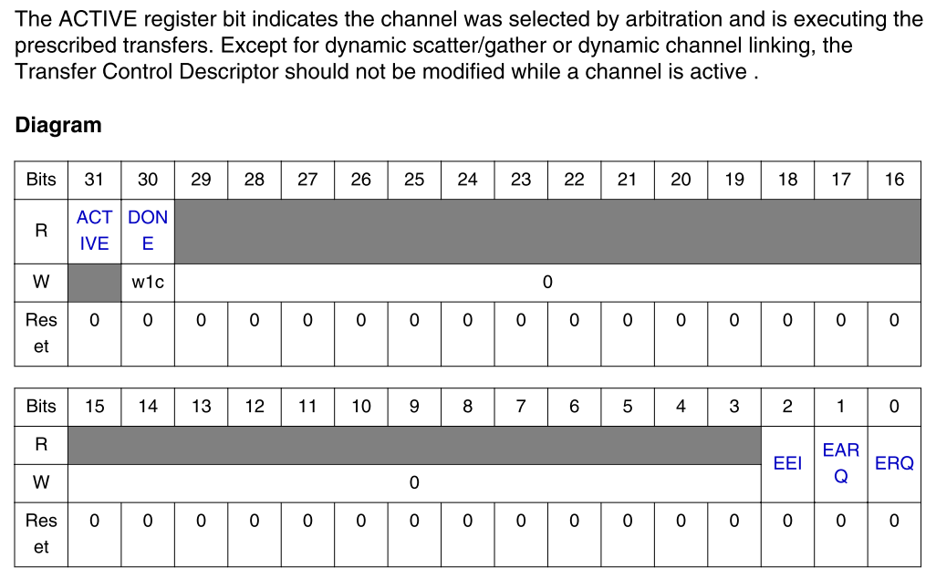

### DMA3_CH_PRI

通道优先级设置， 0-7， 7最大

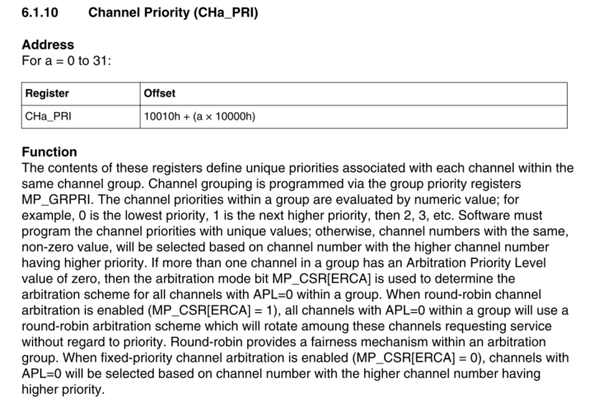

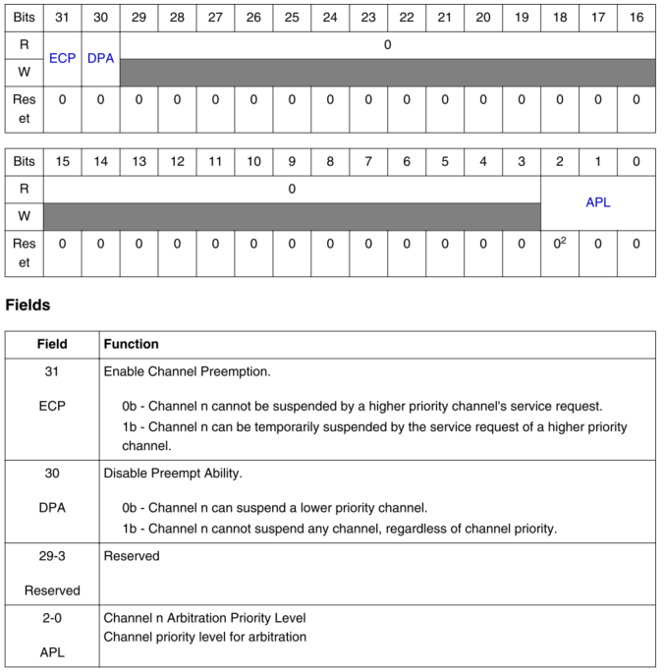

### DMA3_GRPRI

设置Group优先级,优先级0-31,31最大

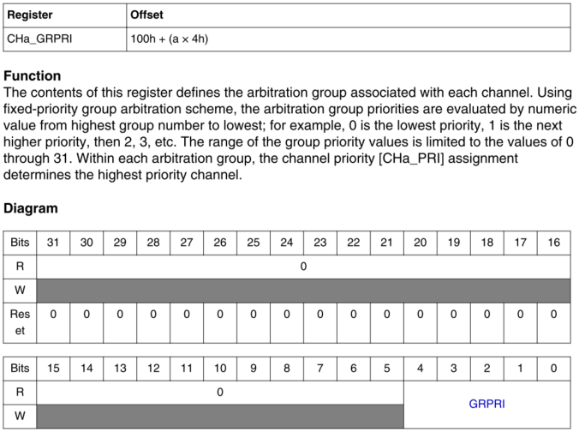

# Makefile

#!/bin/sh

cd /home/imxrt1180_verif3/richard_nxa28190/RT_1.30.GLS00.V01/testbench/blocks/soc_tb/tool_data/verilog

set -e

# Invoke stimulus makefile

/home/imxrt1180_verif3/richard_nxa28190/RT_1.30.GLS00.V01/testbench/blocks/soc_tb/tool_data/verilog/verilog_FILENAMES_awv071676.cn-sha01.nxp.com_85014/run_make_stim.sh

# Invoke the simulator

/home/imxrt1180_verif3/richard_nxa28190/RT_1.30.GLS00.V01/testbench/blocks/soc_tb/tool_data/verilog/verilog_FILENAMES_awv071676.cn-sha01.nxp.com_85014/runsim.sh

# Echo the command line string to stdout and the simulation log file

echo "Stingray command line: soc verilog -irun -block soc_tb -bc rtl -tc default -vectors dma3 -test dma3_interrupt_core_a_inst2_test_5 -shm -keeptemps -session default_5" | tee -a /home/imxrt1180_verif3/richard_nxa28190/RT_1.30.GLS00.V01/testbench/blocks/soc_tb/vectors/dma3/logfiles/dma3_interrupt_core_a_inst2_test_5verilog_default_5.log

第一个makefile /home/imxrt1180_verif3/richard_nxa28190/RT_1.30.GLS00.V01/testbench/blocks/soc_tb/testbench/makefile.stimulus

# Testbench overview knowledge

<https://nxp1-my.sharepoint.com/personal/bill_cui_nxp_com/_layouts/15/onedrive.aspx?id=%2Fpersonal%2Fbill%5Fcui%5Fnxp%5Fcom%2FDocuments%2FRecordings%2F2022%5F05%20onboard%20New%20hire%20Q%26A%20serial%2D20220614%5F164854%2DMeeting%20Recording%2Emp4&parent=%2Fpersonal%2Fbill%5Fcui%5Fnxp%5Fcom%2FDocuments%2FRecordings&ct=1656311680338&or=Teams%2DHL&ga=1>

# Module description

## TCD

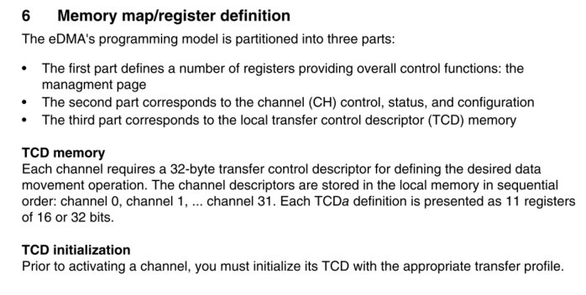 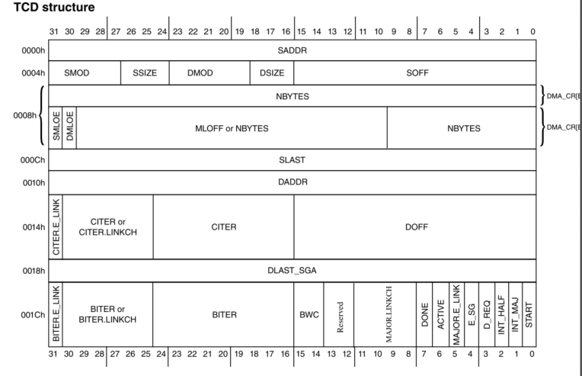

## Channel preemption

通道抢占.DMA允许某个channel在执行的时候，被另一个高级别的channel抢占通信，被抢占的通道挂起，等待抢占成功的channel完成传输后再继续没有完成的数据传输。

1. Channel preemption is enabled on a per-channel basis by setting the CHa_PRI[ECP] bit.
2. A channel’s ability to preempt another channel can be disabled by setting CHa_PRI[DPA].
3. When Round-Robin channel arbitration mode is enabled, MP_CSR[ERCA] = 1, any channel with a priority level equal to zero, CHa_PRI[APL] = 0, has preemption disabled and will not preempt another

channel.

#### Channel priority

Group priority -> channel priority

DMA3_GRPRI DMA3_CH_PRI

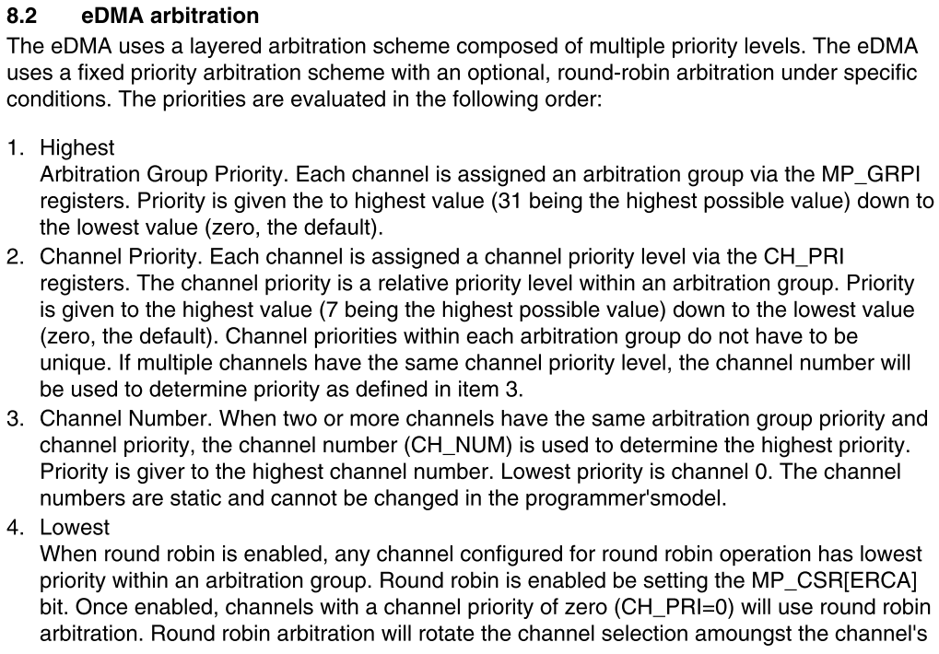

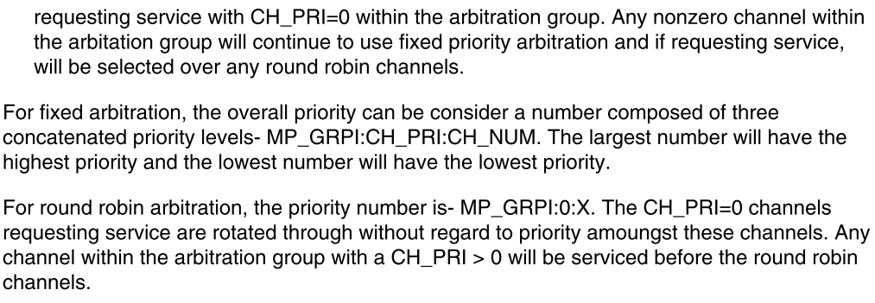

## Scat/gather

DMA支持将TCD的配置写入RAM中，DMA从RAM中获取TCD配置并写入TCD寄存器。TCD的结构参考TCD

当正在执行的channel major loop结束后，DMA会根据配置将TCD的内容写入TCD寄存器。

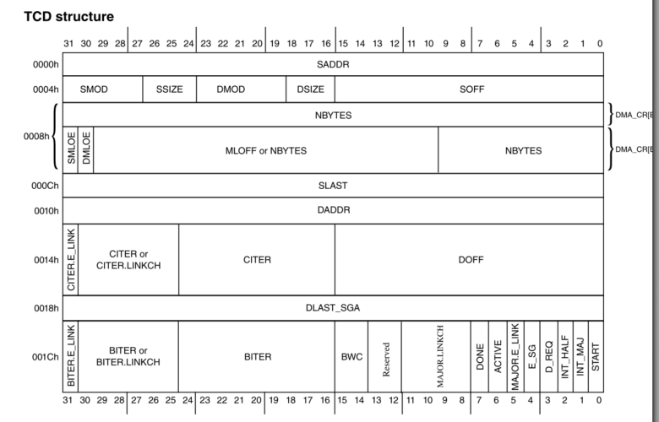

### Example

// Set TCD content into the RAM

// Loading TCD content to memory

WR32(REG32(TCM_SYS_MIDDLE), OCRAM2_BASE); // for TCD_SADDR

WR32(REG32(TCM_SYS_MIDDLE+0x04),0x02020004); // for TCD_SOFF and TCD_ATTR

WR32(REG32(TCM_SYS_MIDDLE+0x08),0x00000040); // for TCD_NBYTES

WR32(REG32(TCM_SYS_MIDDLE+0x0c),0); // for TCD_SLAST

WR32(REG32(TCM_SYS_MIDDLE+0x10),OCRAM2_BASE+0x1000); // for TCD_DADDR

WR32(REG32(TCM_SYS_MIDDLE+0x14),0x00010004); // for TCD_DOFF and TCD_CITER

WR32(REG32(TCM_SYS_MIDDLE+0x18), 0); // for TCD_DLASTSGA

WR32(REG32(TCM_SYS_MIDDLE+0x1c), 0x00010008); // for TCD_CSR and TCD_BITER

RE16(REG16(TCM_SYS_MIDDLE+0x1e), 0x0001); // for TCD_CSR and TCD_BITER

RE16(REG16(TCM_SYS_MIDDLE+0x1c), 0x0008); // for TCD_CSR and TCD_BITER

//Enable E_SG in TCD_CSR register DMA3_TCD_CSR

dma3_ch_set_csr(dma3_context, 0, 0x10); // enable e_sg

// set the scat/gather RAM address DMA3_TCD_DLAST

W32(DMA3_TCD_DLAST(0), TCM_SYS_MIDDLE+0x400000); // scatter_gathering address, set the aliased address into the register

当一个channel major loop结束后，根据如上的配置会重新加载TCD的数据到寄存器中。

然后手动启动TCDn_CSR[start]，再次执行该channel的时候，就会按照重新load的TCD进行数据传输。

## Channel linking

DMA支持使用channel linking的方式来启动相关channel的数据传输。

当手动设置TCDn_CSR[start]启动一个channel后，在该channel的minor/major loop结束后，根据TCD_CITER[ELINK]或者TCD_CSR[MAJORELINK]的配置，DMA自动启动该linking的channel，而不需要手动配置TCDn_CSR[start]

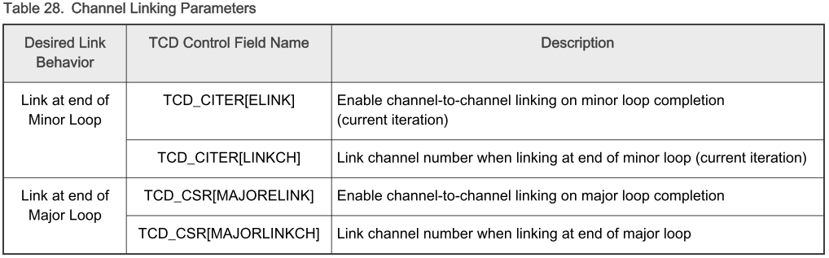

### Example

DMA3_TCD_CITER DMA3_TCD_CSR

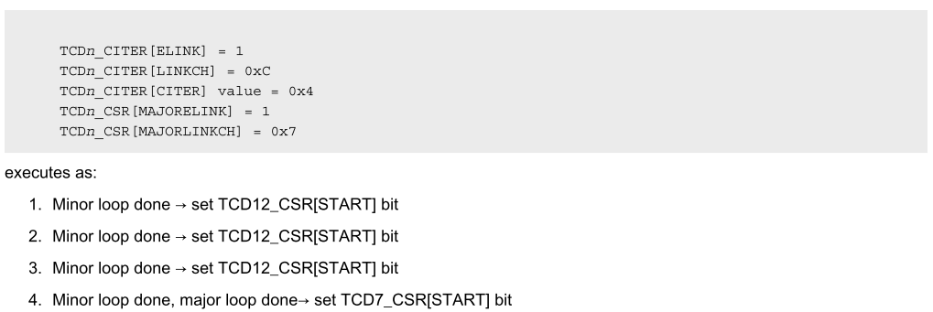

如上配置了4个minor loop（TCDnCITR[citer] = 4）.

TCDn_CSR[start] 启动该nchannel后，当第一个minor loop结束。自动连接到TCDn_CITER[ELINK]设置的channel C进行数据传输

每个minor loop结束，Citer的值减少1，执行一次channel 12的数据传输

当major loop结束，也就是达到了TCDnCITR[citer] 设置的4次loop。自动启动TCDn_CSR[MAJORELINKCH]对应的channel 7，进行channel 7的数据传输。

## Channel SBR

1. MP_CSR （control status register）寄存器GMRC(global master ID replication control)置1

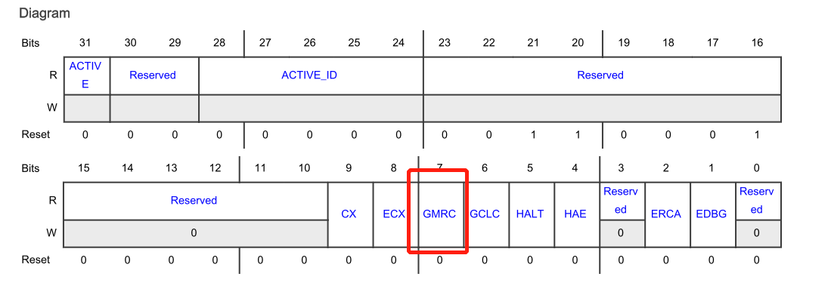

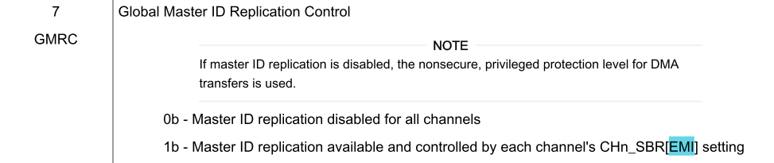

1. CHn_SBR(channel system bus)寄存器，EMI(enable master ID replication)置1

